History
Chapter 2
The Expansion of British Power
- Since the ancient period, India was an important trading centre.
- In course of time, the nature of trade had changed.
- Trading networks had opened up and now instead of individual merchants, companies came to be formed that engaged in trade.
- The English East India Company was one such company.
- It was started by a group of merchants. Queen Elizabeth - I granted them the exclusive right to trade with the east.
- This meant that the English East India Company had a monopoly in England to trade with the east.
- No other English trading company could compete.
- However, other European trading companies from Portugal, Denmark, France began trading with India.
https://youtu.be/T2awYa-4ghU
Do you know that the British East India company officials, merchants and traders were called 'factories' because the officials of the East India Company were called 'factors'?
Due to commercial rivalry, the French were in constant conflict with the English in India.
The French Company's trade increased ten times, which was a big threat to the English. From 1742 onwards, political motives dominated over commercial gains.
Duplex came as the Governor of the French East India Company.
The French power reached its peak during his governorship.

The Anglo-French rivalry is important as it played a role in shaping the course of modem India.

The Carnatic Wars were a series of military conflicts on the Indian subcontinent between the French and the English East India Company.

The three wars were fought between 1746 and 1763.
They fought in the region of the Camatic.
Ultimately, the French were defeated.
This brought an end to French ambitions in India.
From then onwards, the British established their power and gradually, the company changed from a commercial trading association to a political power.
https://youtu.be/0PJdZm1IN-Q

gk
(Bombay came under the possession of the British crown in 1662 and was handed over to the East
India Company for 10 pounds( at present 95.92rs) a year in 1668.

The Mughal Emperor had granted special privileges to the East India Company; the East India Company could trade without paying taxes.

After the death of Aurangzeb, Bengal was ruled by nawabs who were virtually independent of Mughal rule.

The agents of the East India Company began to misuse the Privileges

This made the Nawab unhappy because there was loss of revenue.

This led to a conflict between the East India Company and the Nawab.

The reasons were
(i) the East India Company fortified Calcutta without the permission from Sirajuddaulah.
(ii) stocked ammunition within the fort without the Nawab's permission

(iii) imposed taxes on goods entering Calcutta.
(iv) stopped paying taxes
(v) undermined the authority of the Nawab and insisted that for trade to be profitable, the custom duties had to be removed.

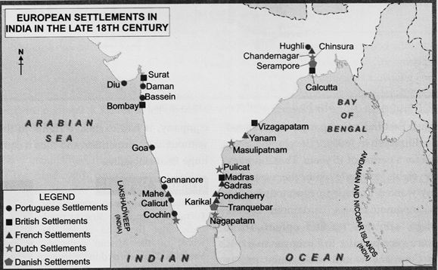

Battle of Plassey 1757
https://youtu.be/8HEl9E70SxU

The Battle of Plassey was the decisive battle that marked the beginning of British rule in India.

Sirajuddaulah 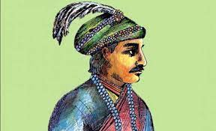

Sirajuddaulah asked the British to demolish the fortifications, but they paid no heed.
According to them, to build up the trade, forts had to be built. They also refused to pay the revenue.

The Young Nawab attacked the British factory at Kassim bazaar and locked the warehouses and imprisoned the officials.

Then, he marched to Fort William and defeated the British easily.
The British sent the ambitious General Robert Clive to take charge and defeat the Nawab of Bengal.
ROBERT CLIVE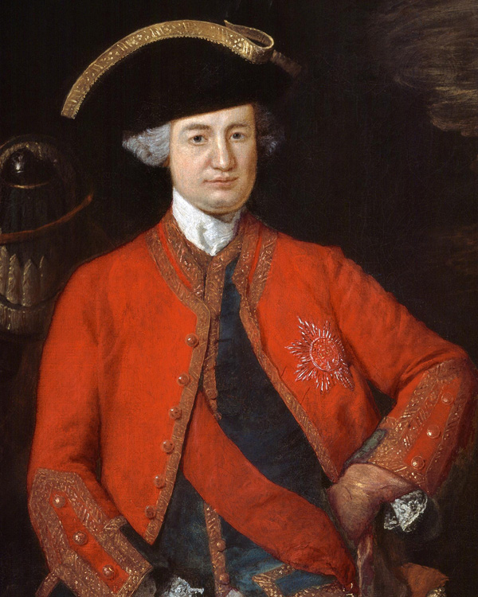

Clive was a military genius.

On June 23rd, 1757, the armies of Siraj-Ud-Daulah and East India Company faced each other in Plassey.

The Nawab's forces were huge as compared to the British army.

The Nawab was betrayed by Mir Jafar, the commander of his army.
He was in charge of a large section of the army and refused to fight as he had been bribed by Robert Clive.

Also, rainfall had made the Nawab's artillery unfit for use.
The Nawab was defeated by the British army and captured.

History Reveals

The army of Nawab Sirajuddaulah was huge as compared to the British forces.

But at the end of the Battle of Plassey, the British lost only 22 men and 50 were wounded.

The Nawab lost 500 men of his army.

Mir Jafar was made the Nawab of Bengal but with limited power.

The Company was granted undisputed right to free trade in Bengal, Bihar and Orissa.

It also received the zamindari of 24 parganas near Calcutta.

Mir Jafar had to pay a huge sum of money as compensation for the attack on Calcutta.

The financial bleeding of Bengal had begun.
The Company continued demanding more and Mir Jafar was unable to fulfil their demands.

He tried to conspire(drive out) with the Dutch to expel the East India Company from Bengal.

The Company now became unhappy with him and his son-in-law, Mir Qasim was made the Nawab.

He had to give the Company officials gifts amounting to 27 lacs and the zamindari of three more districts.

After this battle, the Company got control of the rich Province of Bengal.
The British now monopolised Bengal's trade and commerce and plundered the province.
Thus, the Battle of Plassey had far reaching consequences.

Q. Why is the Battle of Plassey important in the history of India?

Battle of Buxar 1764
https://youtu.be/RG-R_Nt-Gr8

Mir Qasim took steps to stop the misuse of dastaks(si for private trade.
He worked towards improving the efficiency of revenue collection and also reorganised the army.

The British wanted a puppet ruler but Mir Qasim wanted to be independent of their control.

Thus, war was inevitable. Mir Qasim allied with the Nawab of Awadh and the Mughal Emperor, Shah Alam- II.

Their combined forces confronted(faced) the British forces at the Battle of Buxar in October 1764.

The British emerged victorious.

Mir Qasim escaped.

The British now got the right to free trade in Awadh and the diwani rights of Bengal, Bihar and Orissa from the Mughal Emperor in 1765.

The political power was in the hands of the British.

Mir Zafar was again the nawab of Bengal.

He had to pay huge sums of money as the Company wanted more money to meet its war expenses and expand its territories.

After getting the diwani rights over Bengal, the Company now had access to the rich resources of Bengal.

The Company now carried on trade with the revenue it got from Bengal.
They used this revenue to buy Indian products to sell in the European markets and maintain armies.

British-Mysore Conflict
https://youtu.be/_oXAxX9QEpk

Mysore was an important state under the leadership of two great rulers, Haider Ali and his son Tipu Sultan.

The British wanted to annex Mysore because it had a flourishing spice trade.

Also, Mysore was an ally of the French who were helping them to modernise their army.

Also, they had a profitable spice and sandalwood trade.

The British realised the threat posed by Haider Ali.
Four Anglo-Mysore wars were fought between 1767 to 1799.
Tipu Sultan succeeded his father Haider Ali and continued the wars.
The Third Anglo-Mysore War was fought between the British and Tipu Sultan in 1790.

This time the British triumphed(got victory). The war was concluded with the Treaty of Srirangapatam in 1792.

Tipu had to surrender huge territory to the British as well as pay huge war indemnity.

Tipu Sultan wanted to take revenge and get back his territory.
He refused to accept the subsidiary alliance and this resulted in the Fourth Anglo Mysore War in 1799.
Tipu died fighting bravely and later the Subsidiary alliance was imposed on Mysore.
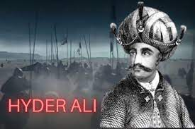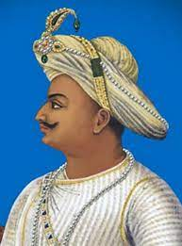

British-Maratha Conflict
https://youtu.be/WoUIVtm6mXY

The British had growing ambitions regarding the Maratha Empire.
The Marathas had been defeated in the Third Battle of Panipat in 1761.
Their power was curbed and thereafter the Maratha state was a confederacy of four chiefs under the nominal leadership of the Peshwa at Poona.
The Chiefs were the Holkars, Sindhia, Gaikwad and Bhonsle.

The Marathas and the British fought three wars between 1775-1819.
The First Anglo Maratha War was fought because of British interference in the affairs of the Marathas.
It was concluded by the Treaty of Salbai in 1782.
This gave the British 20 years of peace with the Marathas.
The Second Anglo-Maratha War arose initially from the internal conflict within the Maratha Confederacy.
It was fought between the Maratha Chiefs and the British.
The British won and in the period three major treaties were signed between the Maratha Empire and the British Empire,
in which the British got many of the Indian territories.
History Reveals
According to the Treaty of Srirangapatnam, the British kept two sons of Tipu Sultan as hostages.(prisoners)

The Third Anglo Maratha War was a desperate attempt by the Marathas to regain their independence.

They were defeated and now the British became the supreme authority in India.

The Maratha Empire completely ended after these wars.

